Lifestyle Corner: Must-Attend Sports Events this Winter in Saudi Arabia!

Saudi Arabia’s ambition of becoming the region’s sports hub is off to a hot start. The recently hosted Saudi Arabian Grand Prix F1 race held on December 5 in Jeddah shattered numerous international TV viewing recordings and was the second-most viewed F1 race ever broadcast on ESPN 2.
The future promises to be no different as the Kingdom has announced several sporting events which will build off this momentum, and firmly cement its status as leader for all things sports in the region.
Here is a list of some of the most anticipated sporting events in Saudi Arabia in 2022:

Dakar Rally
When: January 1-14
Where: Ha’il – Riyadh – Jeddah
The 2022 Dakar Rally marks the third time the race will be held in Saudi Arabia. As with the two previous races, the event will feature 12 stages during a span of two weeks. Starting in the city of Jeddah, the race will cover a distance of over 5,200 miles and pass through a total of six cities and several historic villages. In all, 578 motor bikes, ATV quad vehicles, off-road vehicles, cars, and trucks will race through sand, rock, dirt, and tarmac surfaces to capture grand prizes within their respective categories.
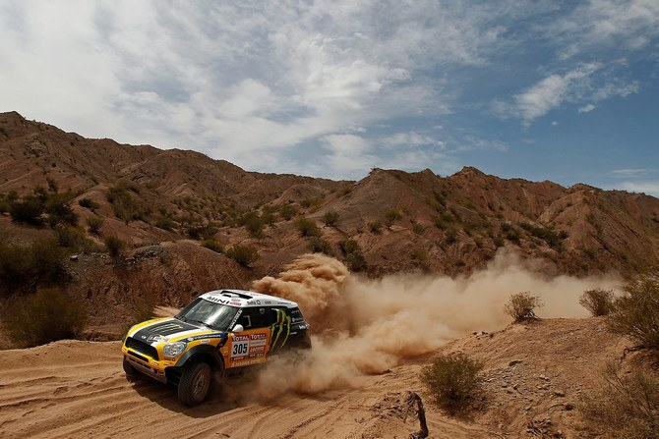
Spartan Race
When: January 21
Where: Riyadh
The second edition of Spartan Race is returning to the Kingdom after a two-year hiatus. Hosted by the Saudi Sports for All Federation, the event will take place on January 21, 2022 in Riyadh’s “Dirab Park” from 7:00 am to 4:00 pm. The 6.2-mile race will include a total of six stages and encompass 25 various obstacles, including mud, water, fire, and barbed wire. The event is open to both males and females and kids aged four and above. To participate in the event, register here by January 20, 2022. The event also invites spectators to attend, watch the races, and enjoy various side activations and other entertainment.
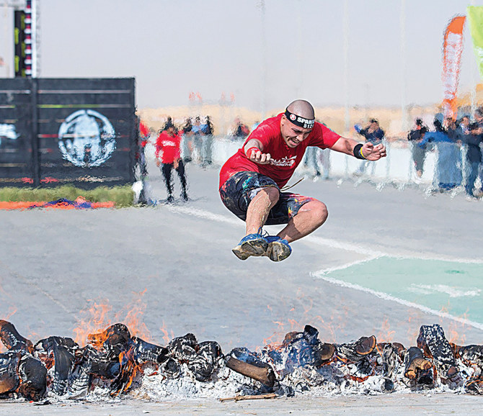

PSG vs. Al-Hilal
When: third week of January 2022
Where: Riyadh
Lionel Messi, one of the best and most celebrated soccer player of all time, is coming to Saudi Arabia! In what promises to be an exciting match, the French team Paris Saint-Germain F.C., or “PSG,” is taking on a star-studded, all-star Saudi team comprised of Riyadh-based “Al-Hilal” and “Al-Nasr” players. The festivities are a part of Riyadh Seasons, which you can read more about here. The event does not yet have an exact date but is scheduled for the third week of January 2022. Ticket information will be found on this page once announced by the event organizers.
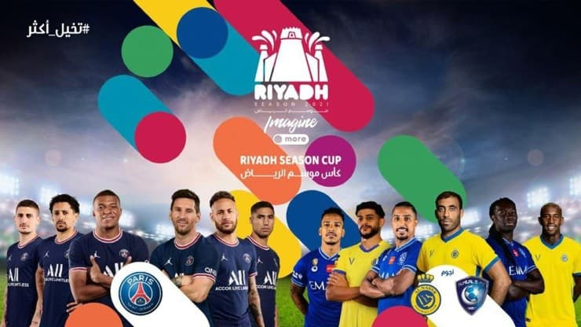

Diriyah E-Prix 2022
When: January 28-29
Where: Diriyah
For the fourth time in as many years, the all-electric ABB FIA Formula E World Championship season is set to kick off in the historic town of Diriyah on the outskirts of Riyadh. The unique competition represents the season’s only night-time race, a 21-turn circuit of twists and turns illuminated with LED lights. In addition to spectating the race, visitors can visit the event’s “Allianz E-Village,” a dedicated fan festival offering entertainment, an opportunity to explore the racing series, and other attractions. The event is further expected to announce a line-up of global performers to celebrate the season opener. For more information on the event or to purchase tickets, please click here.
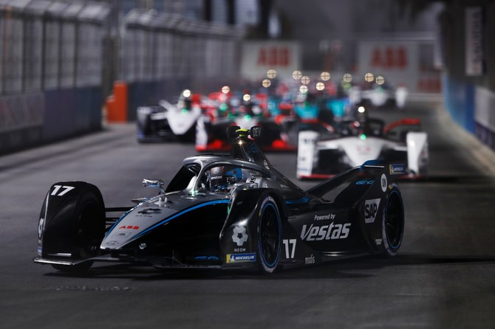

The 2022 Saudi International
When: February 3-6
Where: King Abdullah Economic City
The much-anticipated 2022 Saudi International Golf Tournament makes its debut within the Asian Tour on February 3, 2020. Many of the sport’s top talents, including Phil Mickelson, Sergio Garcia, Dustin Johnson, and other top ranked players have already committed to joining the tournament in pursuit of the $5 million top prize. The event will be broadcast live from the Royal Greens Golf and Country Club in King Abdullah Economic City, a premiere golf resort which offers a state-of-the-art golf course, international dining, luxury spa treatment, and a kids’ club for families. Ticket information will be found on this page once announced by the event organizers.
